**Part 1—Filling our Tables with Data**

**First Vidcast:**

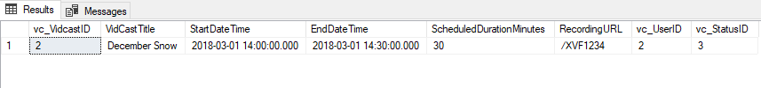

**Saul’s First VidCast:**

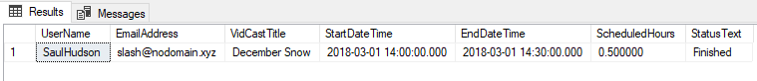

**Update User:**

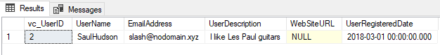

**No more on time:**

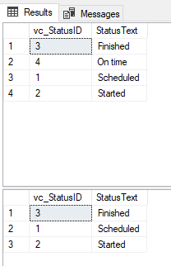

**Part 2—Putting All Together**

**Tags:**

INSERT INTO vc_Tag (TagText,TagDescription)

VALUES

('Personal', 'About people'),

('Professional', 'Business, business, business'),

('Sports', 'All manner of sports'),

('Music', 'Music analysis, news, and thoughts'),

('Games', 'Live streaming our favorite games')

SELECT * FROM vc_Tag

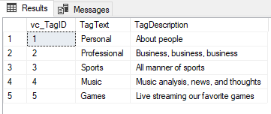

**Users:**

INSERT INTO vc_User (UserName, EmailAddress, UserDescription)

VALUES

('TheDoctor', 'tomBaker@nodomain.xyz', 'The definite article'),

('HairCut', 'S.todd@nodomain.xyz', 'Fleet Street barber shop'),

('DnDGal', 'dnd@nodomain.xyz', NULL)

SELECT * FROM vc_User

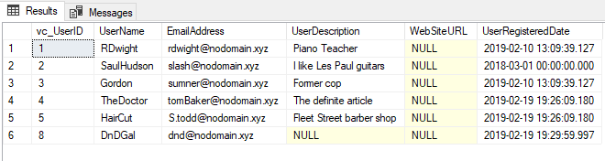

**User Tag List:**

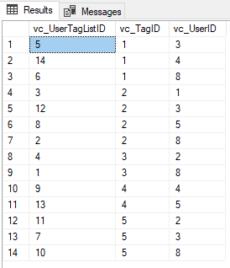

**User Tags Report:**

SELECT

vc_user.UserName,

vc_user.EmailAddress,

vc_Tag.TagText

FROM vc_UserTagList

JOIN vc_User ON vc_User.vc_UserID = vc_UserTagList.vc_UserID

JOIN vc_Tag ON vc_UserTagList.vc_TagID = vc_Tag.vc_TagID

ORDER BY vc_User.UserName, vc_Tag.TagText

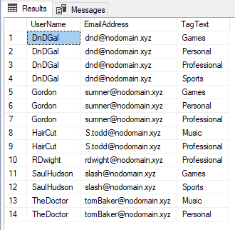

**LMS:**

--Adding a row to the vc_Status table

INSERT INTO vc_Status (StatusText)

VALUES ('Scheduled')

--the following line shows all of the rows in vc_Status

SELECT * FROM vc_Status

--Adding three more rows to the vc_Status table

INSERT INTO vc_Status (StatusText)

VALUES ('Started'), ('Finished'), ('On time')

SELECT * FROM vc_User WHERE UserName = 'SaulHudson'

SELECT * FROM vc_Status WHERE StatusText = 'Finished'

INSERT INTO vc_VidCast

(VidCastTitle, StartDateTime, EndDateTime, ScheduledDurationMinutes, RecordingURL, vc_UserID, vc_StatusID)

VALUES

('December Snow', '3/1/2018 14:00', '3/1/2018 14:30', 30, '/XVF1234', 2, 3)

--Read all rows from vc_VidCast

SELECT * FROM vc_VidCast

SELECT

vc_User.UserName,

vc_User.EmailAddress,

vc_VidCast.VidCastTitle,

vc_VidCast.StartDateTime,

vc_VidCast.EndDateTime,

vc_VidCast.ScheduledDurationMinutes / 60.0 as ScheduledHours,

vc_Status.StatusText

FROM vc_VidCast

JOIN vc_User ON vc_VidCast.vc_UserID = vc_User.vc_UserID

JOIN vc_Status ON vc_VidCast.vc_StatusID = vc_Status.vc_StatusID

WHERE vc_User.UserName = 'SaulHudson'

ORDER BY vc_VidCast.StartDateTime

--Correcting a User's UserRegisteredDate

UPDATE vc_User SET UserRegisteredDate = '3/1/2018' WHERE UserName = 'SaulHudson'

SELECT * FROM vc_User WHERE UserName = 'SaulHudson'

--See what rows we have in status

SELECT * FROM vc_Status

--Delete the On time status

DELETE vc_Status WHERE StatusText = 'On time'

--See the effect

SELECT * FROM vc_Status

INSERT INTO vc_Tag (TagText,TagDescription)

VALUES

('Personal', 'About people'),

('Professional', 'Business, business, business'),

('Sports', 'All manner of sports'),

('Music', 'Music analysis, news, and thoughts'),

('Games', 'Live streaming our favorite games')

SELECT * FROM vc_Tag

INSERT INTO vc_User (UserName, EmailAddress, UserDescription)

VALUES

('TheDoctor', 'tomBaker@nodomain.xyz', 'The definite article'),

('HairCut', 'S.todd@nodomain.xyz', 'Fleet Street barber shop'),

('DnDGal', 'dnd@nodomain.xyz', NULL)

SELECT * FROM vc_User

INSERT INTO vc_UserTagList (vc_UserID, vc_TagID)

VALUES

((SELECT vc_UserID FROM vc_User WHERE UserName='DnDGal'),

(SELECT vc_TagID FROM vc_Tag WHERE TagText='Sports')),

((SELECT vc_UserID FROM vc_User WHERE UserName='DnDGal'),

(SELECT vc_TagID FROM vc_Tag WHERE TagText='Professional')),

((SELECT vc_UserID FROM vc_User WHERE UserName='RDwight'),

(SELECT vc_TagID FROM vc_Tag WHERE TagText='Professional')),

((SELECT vc_UserID FROM vc_User WHERE UserName='SaulHudson'),

(SELECT vc_TagID FROM vc_Tag WHERE TagText='Sports')),

((SELECT vc_UserID FROM vc_User WHERE UserName='Gordon'),

(SELECT vc_TagID FROM vc_Tag WHERE TagText='Personal')),

((SELECT vc_UserID FROM vc_User WHERE UserName='DnDGal'),

(SELECT vc_TagID FROM vc_Tag WHERE TagText='Personal')),

((SELECT vc_UserID FROM vc_User WHERE UserName='Gordon'),

(SELECT vc_TagID FROM vc_Tag WHERE TagText='Games')),

((SELECT vc_UserID FROM vc_User WHERE UserName='HairCut'),

(SELECT vc_TagID FROM vc_Tag WHERE TagText='Professional')),

((SELECT vc_UserID FROM vc_User WHERE UserName='TheDoctor'),

(SELECT vc_TagID FROM vc_Tag WHERE TagText='Music')),

((SELECT vc_UserID FROM vc_User WHERE UserName='DnDGal'),

(SELECT vc_TagID FROM vc_Tag WHERE TagText='Games')),

((SELECT vc_UserID FROM vc_User WHERE UserName='SaulHudson'),

(SELECT vc_TagID FROM vc_Tag WHERE TagText='Games')),

((SELECT vc_UserID FROM vc_User WHERE UserName='Gordon'),

(SELECT vc_TagID FROM vc_Tag WHERE TagText='Professional')),

((SELECT vc_UserID FROM vc_User WHERE UserName='HairCut'),

(SELECT vc_TagID FROM vc_Tag WHERE TagText='Music')),

((SELECT vc_UserID FROM vc_User WHERE UserName='TheDoctor'),

(SELECT vc_TagID FROM vc_Tag WHERE TagText='Personal'))

SELECT

vc_user.UserName,

vc_user.EmailAddress,

vc_Tag.TagText

FROM vc_UserTagList

JOIN vc_User ON vc_User.vc_UserID = vc_UserTagList.vc_UserID

JOIN vc_Tag ON vc_UserTagList.vc_TagID = vc_Tag.vc_TagID

ORDER BY vc_User.UserName, vc_Tag.TagText